Project Name
Pilot Utilisation Plan
ESA Template Ver.2.11, Issue date: 14Mar2024
Approval
Title: Pilot Utilisation Plan
Issue Number: | Revision Number:
Author(s): | Date:
Approved by: | Date of Approval:

Change Log
Reason for change | Issue | Revision | Date

Change Record
Issue Number: | Revision Number:
Reason for change | Date | Pages | Paragraph(s)

Distribution
Name/Organisational Unit:

Table of contents:
1 Introduction 4
1.1 Reference Documents 4
1.2 Acronyms 5
2 Users And other stakeholders 5
2.1 Users and Users’ group description 6
2.2 Peoduct/service utilisation description: users and users’ group roles 6
3 Terms and Conditions for the Pilot Operations 6
4 Conditions to start the pilot and Utilisation Baseline for the Pilot Operations 7
4.1 Conditions to start the Pilot 7
4.2 Pilot Set-up process 7
4.2.1 Acquisition of the users 7
4.2.2 Site installation process 8
4.3 Utilisation Baseline 8
4.4 Pilot planning summary 8
4.5 Mitigation plan in case of delays 8
4.6 Pilot Operation Summary Report 8
5 PROCESS for the Assessment of the product/service 10
5.1 Methodology 10
5.2 Pilot objectives 10
5.3 Key Performance Indicators 10
5.3.1 KPIs characteristics 10
5.3.2 KPIs definition 11
5.3.3 KPIs summary table 12
5.3.4 Other important KPIs 12
6 Reports and evaluation 12
7 Exceptions Handling 13
8 DIGITAL MEDIA REPORTING 13
9 Conclusions 13
10 Annexes 15
10.1 ANNEX 1 (Questionnaires) 15
10.2 ANNEX 2 (Agreements) 15

Introduction
The Pilot Utilisation Plan (PilUP) is a practical guide to how the pilot shall be run. It demonstrates that the consortium has thought about the practical consequences of taking the product and services to the field. The Pilot stage of the project is one of the most hectic parts of the project and it’s easy to lose track of the objectives when trying to solve urgent issues. That’s where the KPIs come in. They help keep you focussed on what things are important, like getting great customer feedback scores and making sure that the product/service is used as much as possible during the Pilot.

This template structures the minimum requirement of content expected in the Pilot Utilisation Plan deliverable to be reviewed by the ESA during the project execution.
Parts with the paragraph title highlighted in green in this template are based on contributions that have been provided in the Full Proposal and that can be reused as starting point and complemented when required.

Concerning the use of this template, please note the following:

- Material presented in this plain style is either suggested content for the Pilot Utilisation Plan, or describes the content to be inserted in the corresponding paragraph, as relevant. This is intended to be an example of a response to the related Agency requirements, which the Contractor needs to properly complement. The suggested material may be adopted as is, or modified at the Contractors’ discretion. It remains the responsibility of the Contractor to ensure that all of the Agency’s requirements present in the Management Requirements are properly addressed.
- This style is used to identify information that must be modified and/or completed by the Contractor for the proposed activity. This supplementary information should be presented in plain typeface (i.e. not red) in the final version of the Pilot Utilisation Plan.
- This style is used for explanatory notes and guidance to help you to develop the Pilot Utilisation Plan content (e.g. to indicate a selection between mutually-exclusive options). This information should be removed from the final version of the document.
PLEASE, REMOVE THIS TEXT BOX AFTER YOU HAVE STARTED USING THIS TEMPLATE

Reference Documents
Ref. | Document ID. | Title | Rev.

Acronyms
Tag | Description
PilUP | Pilot Utilisation Plan

Users And other stakeholders

Describe the actors in terms of the organizations or group of users (called user group in this context) that will be involved in the pilot operations and describe the service provided (or the service validation process) and the associated roles by the different participants (developer, service providers, suppliers, users, stakeholders, as applicable). If the user group and customers are different, take it into account.

A graphical representation of the different stakeholders can help to identify the key actors (e.g. in terms of organisations and individuals) involved in the service value chain, and the subset involved in the pilot operations. This is shown in the diagram below:

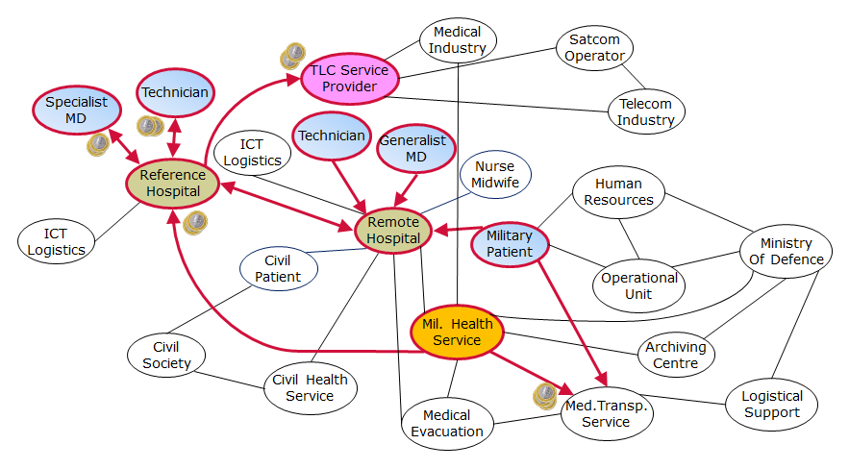
Figure 1 Stakeholders map (example) - in colours, the actors involved in the Pilot Operations

Users group description

Among the actors that will be involved in the pilot operation identified in the previous paragraph select the user group that will be involved in the pilot operations.
Identify what customer segment they are representative (in case the customer segments and use group do not match and their relation is not straightforward) explaining the reason for involving them in the assessment of the preoperational demonstration. You could create a mapping like in the table below.

 | User group 1 | User group 2 | ...
Customer Segment 1 |  | X | X
Customer Segment 2 | X |  | X
... |  | X

Describe the product/service that will be validated with the user group during the pilot stage.
In case there are more user group and more products/services a mapping like that in the table below shall be provided

 | User group 1 | User group 2 | ...
Product/service 1 |  | X
Poduct/service 2 | X
...

Product/service utilisation description: users and users’ group roles
Describe the pre operational services as they will be provided during the pilot, and the way it is supposed to be utilised by the users. In case of necessity provide the different roles the users will have to play during the pilot:
- User group 1
  - Role 1.1
  - Role 1.2
- User group 2
  - Role 2.1

Terms and Conditions for the Pilot Operations
Describe the formal agreements between the Contractor and the group of users involved in the Pilot Operations. The conditions for utilising the product/service (e.g. access to the helpdesk, commitment by the group of users to fulfil the utilisation plan and to contribute to the evaluation, security policy) and the associated administrative provisions (e.g. insurances, responsibilities, liabilities) shall be indicated. Formal agreements signed by the users shall be included in the document (in annex).

In order to participate the pilot users must sign the Agreements Contract describing the formal agreement between the product/service provider and the users. The guidelines can be divided in product/service provider commitments and users’ commitments:

- product/service provider Commitments:
  - Commitment 1
  - Commitment 2
  - ...
- User commitments:
  - Commitment 1
  - Commitment 2
  - ...

Conditions to start the pilot and Utilisation Baseline for the Pilot Operations
Describe the conditions to be met to start the pilot stage: the pilot set-up process, a quantitative baseline of utilisation of the product/service and the associated planning, the pilot planning and the Pilot Operations Summary Report (POSR) template.

This section describes:
- The conditions to be met to start the pilot stage (e.g. formal authorisation to install and operate the platform, approval by specific committees)
- The pilot set-up process
- The quantitative baseline of utilisation of the product/service
- The pilot planning summary
- The mitigation plan in case of delays
- The Pilot Operations Summary Report (POSR)

Conditions to start the Pilot
Describes the objectives to be met as pre-requisite to start the pilot operations. Some examples are listed below:

- XXX sites installed for the validation of the product/service related to user group 1
- YYY sites installed for the validation product/service related to user group 2
- Tools for reporting and evaluation (e.g. log, utilisation statistics, technical status of the pilot, questionnaire on line)
- Operational procedures in place (e.g. Helpdesk, activity monitoring, escalation in case of under-utilisation)

Pilot Set-up process

Acquisition of the users
Describe the process of acquisition of the users.
The users acquisition objectives are
- User group 1: X agreement signed/week starting from dd/mm/yy until XXX is reached.
- User group 2: Y agreement signed/week starting from dd/mm/yy until YYY is reached.
- ...
Note that in some cases agreements with the User groups can be reached before the pilot preparation starts.

Site installation process
Describe the process of installation of the product/service
The objectives are:
- Z sites installed /week starting from dd/mm/yy until ZZZ is reached.
- W sites installed /week starting from dd/mm/yy until WWW is reached.
- …

Utilisation Baseline
Describe the quantitative committed baseline of utilisation of the product/service (e.g. number of utilisation sessions, volume of data exchanged, duration of interactive sessions).
product/service Usage:
- User group 1: minimum usage (unit to be defined )
- User group 2: minimum usage
- …

Pilot planning summary

Put the dates associated to the pilot set-up process, and the pilot operation.
An example of a planning is composed of the following steps:
- Acquire the pilot users of the different users’ group: deadline = dd/mm/yy
- Install the necessary equipment: deadline = dd/mm/yy
- The pilot stage shall operate X months: dd/mm/yy
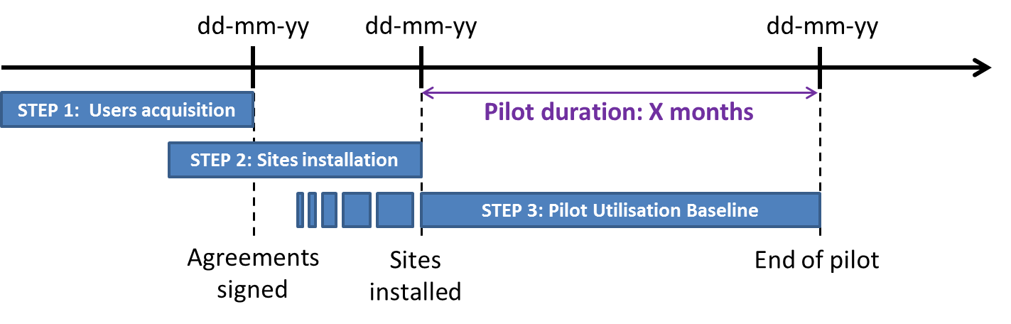
Example of dates and steps with corresponding objectives

Mitigation plan in case of delays
Describe the corrective actions you will perform in case of delays in the planning.

Pilot Operation Summary Report
Describe the structure of the POSR as it has been customised to the specificity of the project. If alternatives tools rather than the POSR are available, their use within the project shall be discussed with the ESA project technical officer (TO).

In case many users will be involved in the pilot, the following parameters shall be monitored in the user’s acquisition process before the pilot starts.
- Users acquired each week
- Site installations completed each week

These shall be compared with the conditions to start the pilot operation. Below an example on how to monitor this in the POSR:

Example of captured objectives in blue and green

Once the installations number will meet the conditions to start the pilot operations, pilot activities can start (and it will be the date of the On-Site Acceptance test milestone)
The parameters defined in the Utilisation baseline shall be monitored during the pilot:

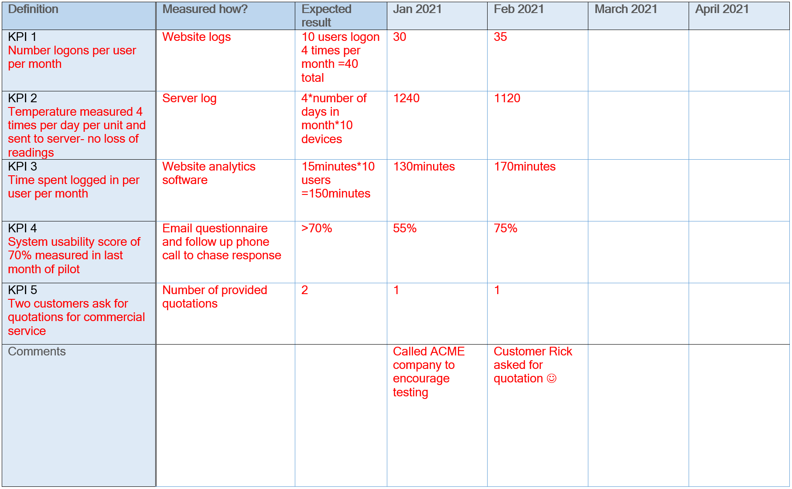

The POSR document can be downloaded from this link

PROCESS for the Assessment of the product/service
This part describes the process that will be used to assess the project outcomes through the added value of the product/service. It defines the means to monitor the outcomes along the pilot stage.

- Define the objectives of the pilot (list of high level objectives technical, business, etc.)
- Identify the KPI and associated metric to assess whether the objectives have been met
- Map each objective to one or more KPI
- Identify an expected value for each of the KPI
- Describe tools and procedures to collect the value of each KPI

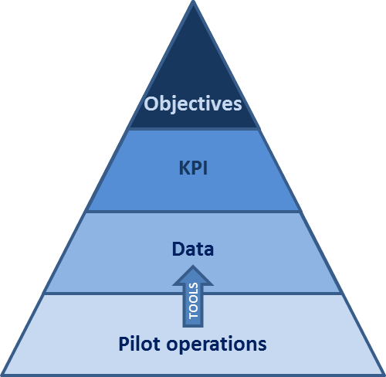
Methodology
The pilot stage is used to validate the developed product and associated services in a representative context. This will allow to verify if the objectives of the project have been met.
The KPIs are defined as (possibly) quantitative indicator to verify whether the objectives of the pilot have been achieved.
To determine these KPIs, data is extracted during the pilot operation. This can be different kind of data such as volume of data traffic, feedback from the users, time saved in the daily operations, value recovered. This data is extracted thanks to different tools (measurements equipment’s, questionnaires, logs, etc.)
Due to the structure of some product/service, the KPIs can be measured at different levels, e.g. measure of the bandwidth per segment, or for the overall network, etc.

Pilot objectives
The objectives of the pilot are ...
- First objective:
- Second objective:
- ……:
The pilot objectives shall be put in relation to the eventual objectives of the whole project.

Key Performance Indicators

KPIs characteristics
The KPIs should reflect the pilot objectives as identified above. All KPIs should have:
- A precise definition of its signification
- A defined metric: the data should have a measurable way to be captured along the process
- A timing: when the data should be monitored, at which frequency is measured and at which reporting frequency is made available to ESA
- A target: an expected value along time
- A process that allows to monitor it: a software tool, a mathematic formula, a procedure agreed with the users

The ability to visualise the results of these KPIs via a web interface would be the best way to publish them, alternatively they can be monitored in a worksheet within the POSR (as done in the POSR Template).

KPIs definition
The following KPIs will be considered:
- Objective 1
  - KPI 1
  - KPI 2
- Objective 2
  - KPI 3
  - KPI 4
…..

KPIs shall be measured during the pilot operation; if they will be measured at the end of the pilot itself a justification should be provided. Ideally KPIs could be reported in the POSR associating them to each day of the pilot operations.
KPIs linked to the utilisation of the product/service (e.g. number of sessions, number of users using the product/service) shall be measured incrementally, on weekly basis, and promptly reported to ESA in the POSR submission.

KPIs summary table
A summary of the KPIs and their characteristics is shown on the template below:

 | KPI | Definition | Expected Value | Report Frequency | Period | Tool to extract the data
Objective 1 | KPI 1 |  | 80% answered 3+ to question 5 | weekly | During the pilot, end of the pilot | Questionnaire
 | KPI 2 |  | XXX | monthly | End of the pilot | Software
Objective 2 | KPI 3
 | KPI 4
Objective 3 | …

Environmental and Social Indicators
Using the embedded Excel below, indicate the relevant Environmental and/or Social Indicators that can be associated to the Pilot Utilisation.

Reports and evaluation
This section will include the evaluation reports of the pilot associated to the analysis of each KPI. Here the pilot results have to be analysed from the users as well as the service provider’s perspective. For each KPI the team shall assess whether the objectives have been met or not, providing an analysis and consideration on what measured.

Each KPI will be extracted from the POSR (or any other available tool). It is up to the contractor to decide how to monitor the KPIs along the pilot stage (e.g. web interface or POSR template for the KPI tracking)

Exceptions Handling
Whenever a significant underperformance episode (e.g. deviation more than 30%) occurs between the measured KPIs and the respective targets for two consecutive weeks, a specific analysis shall be carried out by the coordinator of the Pilot Utilisation to identify possible causes and propose corrective actions.

The underperformance episodes described above shall be reflected into the Risk Analysis either with a new Risk Item (in case the issue was not already covered by the pre-existing risk items) or contribute to the analysis of the relevant existing Risk Item(s).

DIGITAL MEDIA REPORTING

The visual documentation of the pilot operations is a key element which requires adequate attention. For this purpose, the Contractor is invited to document the process of installation, verification, validation and dissemination that will occur in the frame of the project. These images can be used by the company in future dissemination/marketing activities.

The inputs provided by the project will be also used to populate the image database used by ESA to document the Business Apps Projects. The images will be kept in a restricted web space. The image below show the interface used to store the images of the Business Apps Projects under Google Photos.

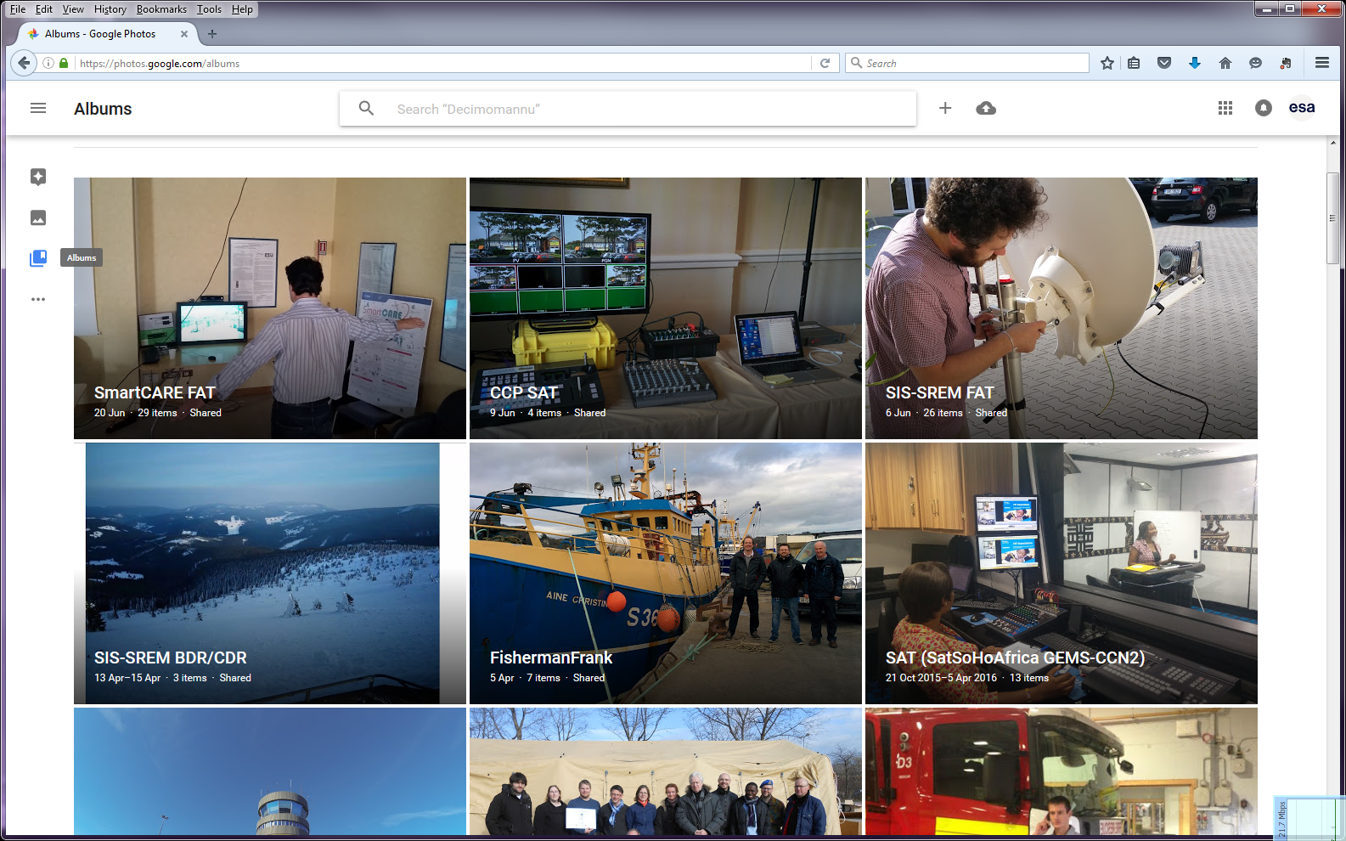
Figure 2 Business Apps Projects - Pictures under Google Photos

Conclusions
The pilot results shall be summarised, providing an overall conclusion on the pilot outcomes.

In order to promote and disseminate the results of the pilot, a summary of the pilot results shall be prepared as a contribution to dissemination materials (like brochures or presentations). The pilot results shall be summarized, providing an overall conclusion on the pilot outcomes.

Annexes

ANNEX 1 (Questionnaires)

AN example of a questionnaire is provided by the System Usability Scale (SUS), see:
https://www.usability.gov/how-to-and-tools/methods/system-usability-scale.html

ANNEX 2 (Agreements)
This annex shall provide the agreement with the pilot users….

