The mandatory Cover Letter Template and the Full Proposal Template can be downloaded in WORD format using the following link:
Space for Aviation Safety Evolution | ESA Business Applications

COVER LETTER “Space for Aviation Safety Evolution”
(ESA Template v.2.0 of 06/07/2020)

[N.B. Please use this template to prepare the Cover Letter of your proposal. Once the Cover Letter is complete and internally validated, please remove all captions in red colour, add your own logos and headers/footers prior to finalising your proposal for submission to ESA.

When submitting to “esa-star” system, separate the Cover Letter from the Full Proposal Template according to the required proposal elements]

COVER LETTER
From: (insert the name of the Tenderer or use your letterhead)
Date: (Tenderer to fill in the date of the Full Proposal)
To: EUROPEAN SPACE AGENCY (ESA),
ECSAT
Fermi Avenue
Harwell Campus
Didcot, Oxfordshire OX11 0FD
United Kingdom
Att.: Ms Adriana Lucas (CIP-PET)
Subject: Space for Aviation Safety Evolution – Open Call for Proposals
Ref.: AO/1-10989/21/UK/AL
Our ref.: Proposal Title (proposal title)
No. (proposal reference number)
___________________________________________________________

Dear Sir or Madam,
With reference to the above Open Call for Proposals, we are pleased to present this proposal for a Demonstration Project addressing …

Validity Period
This proposal is valid for a period of four months from the date of proposal submission to ESA with implicit extensions as per Article 37 points 3 & 4 of the Agency’s Procurement Regulations.

Overview of the Proposed Activity
The proposed activity (very short introduction of the idea).
The proposed start date for the activity is (start date).
We hereby inform the Agency, that we (will/will not) start the work prior to contract award. In the former case, the Agency shall not be held liable of expenses incurred by the Tenderer.

Bidding Team and Price Breakdown
Our Firm Fixed Price for the activity, in accordance with the funding conditions stated in the Announcement of Opportunity, amounts to (total price) Euro all included, with the sole exception of any import duties and value added taxes in the Agency’s Member States. This price is based on a total cost of (total cost)] Euro.

The geographical distribution within the Bidding Team is indicated in the table below.
Geographical Distribution within the Bidding Team
(for Contractor and Subcontractor(s) only, not for suppliers)
 | Percentage of total activity price
Country  (2-letter ISO code) | Total
country 1 | xx %
country 2 | xx %
country …. | xx %

The details of the Bidding Team are as follows:
Bidding Team and Price Breakdown Information (all figures in EUR)
Please fill in the table below and do not forget the obligatin for all components of the proposed bidding team to have at least completed the “ Light Registration” in esa-star Registration.

The information hereunder is to be mirrored in the “ consortium structure” in esa-star)

 | Contractor | Subcontractor 1 | Subcontractor ..
Tenderer’s Complete Name and Legal Nature | ........ | ........ | ........
SME | yes/no | yes/no | yes/no
Large Space Integrator | yes/no | yes/no | yes/no
Entity Code | 1 000 xxx xxx | 1 000 xxx xxx | 1 000 xxx xxx
Country (2-letter ISO code) | XX | YY | ZZ
Price Type | FFP | FFP | FFP
Price and cost | Price €........  Cost €........ | Price €........  Cost €........ | Price €........  Cost €........

Contact Details
Entity and contact details for the Tenderer (potential Contractor) are given below:

Entity Details | Full Name: | (full name of the Tenderer)
Entity Details | Address: | (address of its seat)
Entity Details | Telephone: | ........
Entity Details | Nationality (according to ESA Convention criteria): | ........
Contact person to whom all communication related to the Full Proposal should be addressed: | Name: | ........
 | Telephone nr.: | ........
 | Email address: | ........
 | Postal address: | ........  ........
Author(s) of the Full Proposal: | Name: | ........
Author(s) of the Full Proposal: | Job Title: | ........
Person who will be responsible for the technical management of any resulting contract, and who would be nominated as such in the contract: | Name: | ........
 | Telephone nr.: | ........
 | Email address: | ........
 | Postal address: | ........  ........
Person who will be responsible for the contractual management of any resulting contract, and who would be nominated as such in the contract: | Name: | ........
 | Telephone nr.: | ........
 | Email address: | ........
 | Postal address: | ........  ........
Person who will be responsible for the Personal Data Protection matters of any resulting contract, who would be nominated as the Data Protection contact point in the contract: | Name: | ........
 | Telephone nr.:  Email address:  Postal address: | ........  ........  ........
Legal representative who will sign any resulting contract: | Name:  Postal address: | ........  ........

Contact details for the Subcontractor(s) are given below:
Please fill in the table below and do not forget the obligation for all components of the proposed bidding Team to have at least completed the “Light Registration in esa-star Registration (or delete the above statement and the following table if no subcontractors are proposed)
Subcontractor Contact Details
 |  | Subcontractor 1 | Subcontractor 2 | Subcontractor …
Subcontractor details | Name: | ........ | ........ | ........
Subcontractor details | Address: | ........  ........ | ........  ........ | ........  ........
Contact person for the purposes of their Full Proposal to the Contractor | Name: | ........ | ........ | ........
 | Telephone nr.: | ........ | ........ | ........
 | Email address: | ........ | ........ | ........

Declaration of Compliances
With respect to the “Declaration of Compliances” we herewith officially declare the following:
- In regard to the ESA General Conditions of Tender (GCT), we hereby certify that the legal entities identified in sections 3 above have filled in the Agency Questionnaire in “esa-star”, which has/have been updated not earlier than 12 months before proposal submission.
- Regarding management contents of this proposal, we hereby certify that this tender fully complies with the Management Requirements.
- Regarding financial contents of this proposal, we hereby certify that this tender fully complies with the financial requirements of this Call for Proposal.
- We hereby state that we have read and understood all the terms and conditions of the Draft Contract included in the subject Call for Proposals and that we accept the said terms and conditions without any reservations. (Full and unconditional compliance is expected. However, you are invited to propose how to complete the parts of the Draft Contract which are left blank).
- We confirm that any sales conditions of our own shall not apply.
- We hereby acknowledge the right of the Agency during the validity period of this tender, to require the Tenderer to provide evidence of any element of its proposal and to give additional detailed information, including on the price quotation. This includes the right for the Agency to perform an audit if the Agency deems it appropriate (see Part 2 B7 of the GCT).
- This proposal is consistent with the Outline Proposal approved by the Agency.
- With regard to the requirements in ESA’s Policy on the Prevention, Detection and Investigation of Fraud (see paragraph pecial reference is made to paragraph 11 of the AO cover letter), the tenderer is compliant.
- We hereby explicitly state that we have read, understood and accepted the Personal Data Controller to Controller (PDCC) Annex to the Draft Contract. (This Annex forms an integrated part of the Contract and the Tenderer’s attention is drawn to the fact that it will not be subject of separate signatures. Should the tender lead to a Contract award, the PDCC will enter into force upon signature of the Contract by both Parties.)

Done and signed for, and on behalf of .....................

Signature: ..............................

Name and title of the signatory: (full name and function) duly authorised to commit the tendering entity and its proposed Subcontractor(s) for this purpose.

Where relevant: Signed Letters of Authorisation of Funding are attached as Annex 1 for the following countries: xx, xx, xx.

Annex 1

Letter(s) of Authorisation of Funding from National Delegation(s)

Please enclose a copy of the letter from each relevant National Delegation.

Full Proposal Template for Space for Aviation Safety Evolution

Appendix 4 to AO/1-10989/21/UK/AL

INTRODUCTION
This Full Proposal Template is a tool to help the tenderer to prepare a comprehensive Full Proposal responding to the Space for Aviation Safety Evolution Project.

Please note that, in consideration to the fact that the preparation of the Full Proposal can be started only upon confirmation by ESA that the corresponding Outline Proposal has been accepted, for the purpose of this template it is assumed that several parts of the Full Proposal will be based on information, possibly expanded whenever required, that have been already provided in the Outline Proposal.

Concerning the use of this template, please note the following styles and the related instructions:

- Material presented in this plain style is either suggested content for a Full Proposal, or describes the content to be inserted in the corresponding paragraph, as relevant. This is intended to be an example of a response to the related Agency requirements, which the Tenderer needs to properly complement by activity-specific information. The suggested material may be adopted as is, or modified at the Tenderer’s discretion. It remains the responsibility of the Tenderer to ensure that all of the Agency’s requirements of the present Call for Proposals are properly addressed.

- This style is used to identify information that must be modified and/or completed by the Tenderer for the proposed activity. This supplementary information shall presented in plain typeface (i.e. not red) in the final version of the Full Proposal.
- This style is used for explanatory notes and guidance to help you to develop the Full Proposal content (e.g. to indicate a selection between mutually-exclusive options). This information should be removed from the final version of the Full Proposal.

Use of this Full Proposal Template is mandatory. The Tenderer shall not change the structure of this Full Proposal Template (i.e. the table of contents must remain unchanged) with the exception of Section I for which inclusion depends on the scope of the activity.
Please note that the Full Proposal is the only document that will be considered by the ESA Tender Evaluation Board, which will not have access to the Outline Proposal. Therefore, the Full Proposal shall be considered as a full self-contained document, and the contributions coming from the Outline Proposal shall be explicitly appearing in the Full Proposal.

The length of the completed Full Proposal without Annexes shall not exceed 100 pages (without changing font size or page margins).

Please use this page as the cover page of the Full Proposal and remove the previous three pages (Template Title page and Introduction)

Project Name
Full Proposal for Space for Aviation Safety Evolution Project

Date: …
Reference: ……

INTRODUCTION 8
List of Acronyms 12
A. COVER LETTER 13
B. PROJECT SUMMARY AND RATIONALE 13
B.1 Background Information 13
B.2 Service Description and Selling Point(s) 13
B.3 Space Asset(s) and Rationale 13

C. BUSINESS PLAN 13
C.1 Customer Segments 13
C.2 Value Propositions 14
C.3 Channels 14
C.4 Customer Relationships 15
C.5 Revenue Streams 15
C.6 Key Resources and Dependencies 15
C.7 Key Activities 16
C.8 Key Partners 16
C.9 Service Value Chain 16
C.10 Cost Structure 17
C.11 Market Analysis 18
C.12 Competitive Landscape 20
C.13 Exploitation Plan 20
C.14 Financial Indicators 21
D. TECHNICAL PROPOSAL 23
D.1 User Requirements 23
D.2 System / Service Architecture 23
D.3 Implementation Approach 24
D.3.1Service Maturity 24
D.3.2Implementation Activities 24
D.4 Pilot-Demonstration Service 25
D.4.1 Pilot Objectives and Evaluation 25
D.4.2 Pilot Activities 25
D.5 Technical and Non-Technical Risks 27
D.6 Annex D - Letters of Commitment 28
E. Management and Administrative Proposal 29
E.1 Background experience 29
E.2 Organisation and management 29
E.3 Facilities 29
E.4 Key personnel 30
E.5 Travel and subsistence plan 30
E.6 Monthly Progress Reports 31
E.7 Minutes of Meetings 31
E.8 Project Web Page 31
E.9 Annex E - CV of Key Personnel 32
F. IMPLEMENTATION Proposal 33
F.1 List of Deliverables 33
F.1.1 Documentation and Media 33
F.1.2 Hardware, Software and Manuals 34
F.2 Work Breakdown Structure (WBS) 37
F.3 Work Package Descriptions (WPDs) 38
F.4 Planning 40
F.4.1 Review Milestones 40
F.4.2 Project Schedule 41
G. FINANCIAL Proposal 43
G.1 Cost and Price Summary 43
G.2 PSS Forms 44
G.3 Annex G - PSS Forms 45
G.4 Source of the Entity Contribution 46
G.5 Statement of Profit 46
G.6 Currency and Conversion Rates 46
G.7 Type of Price 47
G.8 Quotations Free of Taxes and Customs Duties 47
G.9 Milestone Payment Plan 47
H. CONTRACTUAL Proposal 50
H.1 Compliance with the Contract Conditions 50
H.2 Insurance Waiver 50
H.3 Statement Relating to Export Import Licences / Authorisations and Related Documentation 50

List of Acronyms
ARTES | Advanced Research in Telecommunication Systems
BDR | Baseline Design Review
BP | Business Plan
CBA | Cost Benefit Analysis
CDR | Critical Design Review
COD | Contract Outcome Data
DM | Digital Media (as part of the FDP)
ESA | European Space Agency
FAT | Factory Acceptance Tests
FDP | Final Data Package
FR | Final Review
FREP | Final Report
HW | Hardware
IAP | Integrated Applications Promotion
IRR | Internal Rate of Return
KSF | Key Success Factor
KPI | Key Performance Indicator
MOM | Minutes of Meetings
MPR | Monthly Progress Report
NPV | Net Present Value
PBC | Project detailed Bar Chart
PD | Portable Demonstrator
PilUP | Pilot-Demonstration Utilisation Plan
POSR | Pilot-Demonstration Operations Summary Report
PSS Forms | Procedures Specifications and Standards Forms, used to break down and give transparency to the total cost and price of the proposal
PWP | Project Web Page
RD | Requirements Document
S&A | Summary and Achievements
SAT | On-Site Acceptance Tests
SSA | System and Service Architecture
SVD | System Verification Document
SW | Software
WBS | Work Breakdown Structure
WP | Work Package
WPD | Work Package Description

COVER LETTER
THE COVER LETTER IS PROVIDED AS A SEPARATE DOCUMENT

PROJECT SUMMARY AND RATIONALE
This section should summarise the following components:

Background Information

Project Name: ……

Prime and contact points: ……

Prime information: ……

Rest of the consortium: ……

Service Description and Selling Point(s)
Description of the product / service you intend to offer

Innovation / key selling point(s) with respect to what is available in the market

How does the proposed final product / service fit within your current business activities and your mid-/long-term strategy?

What is the relevance to the thematic call objectives? Which topic and application area(s) do you propose to address and how?

Space Asset(s) and Rationale
Provide a high-level description of the role of satellite communications in the proposed solution. Indicate any broader use of space technology / space asset(s) intended to be used, the rationale and the added-value of the usage.
A detailed description of the architecture is expected in Section D.2.1

BUSINESS PLAN

Customer Segments
The key customers/customer segments targeted by our product / service are: ……

The pains (e.g. problems) and gains (e.g. benefits) are: ……

The potential customers already identified are: ……

The following table provides a summary overview of the customers and associated high level characterisation in relation to the target product(s).

Table C.1 Key Customers/Customer Segments and their Needs
Customer/Customer Segment | Customer Problems/Needs | Representativeness for the Targeted Market
……… | ……… | ………
……… | ……… | ………
……… | ……… | ………

Value Propositions
The table below identifies the specific characteristics of our product / service that will address the previously-identified customer problems/needs. (e.g. performance, cost, new features) and define its value proposition i.e.: value that the product or service offers to its customers.

Table C.2 Key Product Characteristics
Customer Segment | Problem/Need | Product Characteristics Addressing this Problem/Need | Value proposition
Customer Segment 1 | …… | …… | ……
Customer Segment 2 | …… | …… | ……
…… | …… | …… | ……

Explain the relevance of your value proposition to address user needs in the selected use case(s).

Channels

In the commercial exploitation stage, our product / service will be sold to the customers via these channels: ……

Describe where you will reach and interact with your customer segments, with reference to the following (where applicable):
- Awareness - how do you make the customer aware of the value proposition (e.g. app store, ads, word of mouth...)
- Evaluation - how do you enable the customer to evaluate the value proposition (e.g. reviews, demo's/trials...)
- Purchase - how do you collect payment from customers
- Delivery - how do you deliver the value proposition
- After Sales - how do you support the customers after purchase.

Customer Relationships

Describe how you will interact with customer segments (e.g. personal service, self-service, automated, communities, co-creation model…)…

Our relationships with the key customers already exist / must be created / have to be improved.

Revenue Streams
Describe the sources of revenues made from each customer segment (e.g. product sales, usage/service fees, subscription fees, leasing, licensing, advertising…).

In the commercial exploitation stage, our product / service will be sold to our customers as described in the tables below, based on the market analysis reported in Section C.12.

To justify the assumptions about the price to which the product will be sold, some high level considerations about the Cost Benefit Analysis (CBA) for the customers should be provided. Such considerations should give the rationale that the acquisition of the product for its cost is worthwhile for the customers. Financial tables such as that below can be found in the Financial Indicators Workbook.
Table C.3 Product Pricing
Customer Segment 1(*)
Customer Segment 2
Customer Segment 3
Churn Rate
Product
unit price
Product
installation
charge per
unit
Service fee
per product
per year
Customer Segments
(*) Please use the definition used in Table C.2

Key Resources and Dependencies
To realise our product / service and deliver the value propositions we need the critical resources and dependencies that are defined in the following table, as applicable.

Table C.4 Key Resources and Dependencies
Required Resource | In Place | Potential Issues
……… | yes/no | ………
……… | yes/no | ………
……… | yes/no | ………

Key Activities
To realise our product / service and deliver the value propositions we need to perform the key activities identified in the table (note that this refers to activities expected during provision of the operational service – project implementation activities are requested in Section D.3.2).

Table C.5 Overview of Key Activities
Key Operational Activity | Description
……… | ………
……… | ………
……… | ………

Key Partners
The value chain involves the key partners defined in the table below.

Table C.6 Key Partners
Partner Name  (company name, country, web link) | Background / Experience | Involvement in the Project and/or in commercial exploitation  (e.g. none, subcontractor, supplier, pilot user, customer, integrator) | Type of Agreement  (e.g. NDA, partnership agreement, contract)
……… | ……… | ……… | ………
……… | ……… | ……… | ………
……… | ……… | ……… | ………

Please, take into account partners during the project stage may not be the same as during exploitation (e.g. HW factory producing the designed product may not have a role during the project, but it will be necessary during exploitation). Please explain the status of those relationships (existing, in progress, to be established…) complementary to the info of the table above.

Service Value Chain
The following diagram describes the service value chain including all relevant project partners and their role in the project and in the commercial exploitation stage of the product / service.

Figure C.7 Project Team Composition and Roles
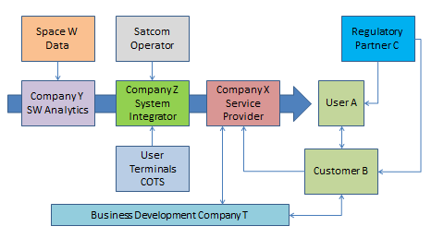

Cost Structure

Describe the sources of costs that you will incur for provision of the operational service (e.g. from reaching customers, maintaining customer relationships, acquiring key resources, performing key activities, establishing key partnerships…).

The key elements of cost for realising the value proposition are presented in the following tables (Financial Indicators Workbook).
Table C.8 Cost of Sales
Jan-18
0
1
2
3
4
5
6
7
8
Commercial Exploitation Phase
Simplified CoS for product
unit
Cost Element N.1
Estimated Cost of Sales
Cost Element N.2
Cost Element N.3
Cost Element N.4
Table C.9 Operational Expenditures
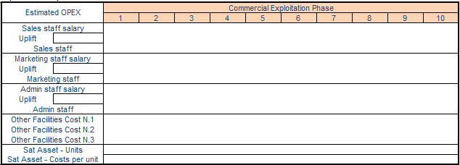
Table C.10 Capital Expenditures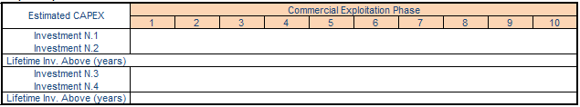
The following assumptions have been used to derive the figures provided in the tables above: ……

Market Analysis
Our product / service is addressing the market of …… (e.g. provide few examples), which has the following characteristics: …. (e.g. size, geographical reach, trends, sales model).

The position of our product / service in the market is summarised in the matrix below.

Table C.11 Market positioning
MARKETS | New (MN) | ………. | ………. | ……….
MARKETS | Adjacent (MA) | ………. | ………. | ……….
MARKETS | Existing (ME) | ………. | ………. | ……….
 |  | Existing (PE) | Incremental (PI) | New (PN)
 |  | PRODUCT / SERVICE

Competitive Landscape
Our key competitors and the nature of the competition are identified in the table below.

Table C.12 Summary of the Competition
Competitor | Characteristics | References | Our Competitive Advantage
……… | ……… | ………
……… | ……… | ………
……… | ……… | ………

Exploitation Plan
Time of commercial entry into the market and way forward to bring the activity results to commercial product / service: ….

Our projection in terms of the market we aim to capture in the short term for each of the identified customer segments is shown in the following table.

Table C.13 Served Obtainable Market 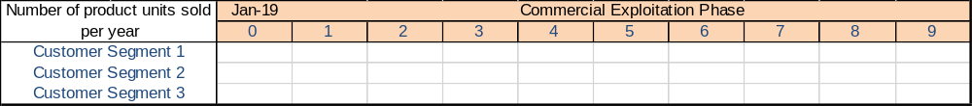
The assumptions behind the above sales projection are ……

Are you compliant with the relevant regulatory framework? Are there regulatory barriers?

Expected economic, social or environmental benefits inside and outside the consortium, and associated timescale: …..

Financial Indicators

A profit and loss and cash flow statement is provided in the table below.

Table C.14 Profit & Loss and Cash Flow Statement
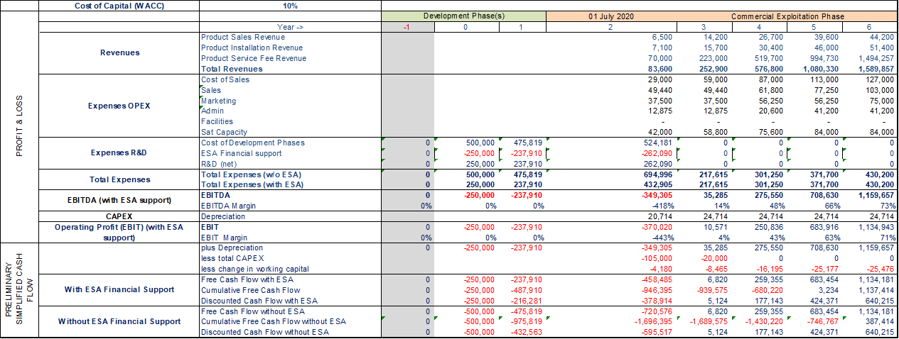

(The above is just an example. The above table can be found in the spreadsheet file - Financial Indicators Workbook)

Table C.15 Financial Indicators with and without ESA Support
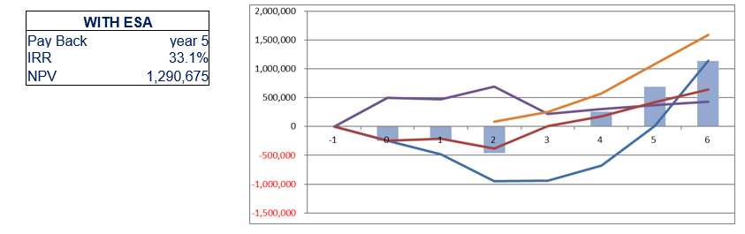
(The above is just an example. The above table can be found in the spreadsheet file)

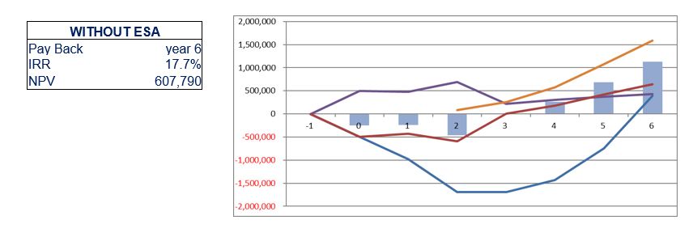

TECHNICAL PROPOSAL

User Requirements
The following table provides a first iteration of the user requirements.

Table D.16 User Requirements
Req. ID | User Requirement Name | Description and Rationale | Related customer segments
UR-A_001 | ……. | ……. | …….
……. | ……. | ……. | …….
……. | ……. | ……. | …….

System / Service Architecture
A high level block diagram of the system / service showing the key attributes and key building blocks and the main interfaces is provided in the below figure.

Table D.17 System/service Architecture
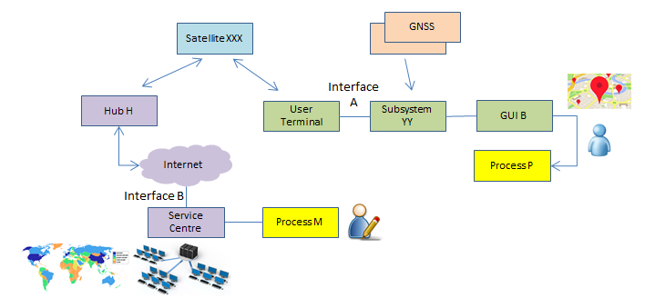
EXAMPLE

With reference to the figure above, the pilot system to be deployed in the proposed activity will consist of the following elements (include a short description of each):

If more than one pilot demonstrator is proposed, identify which parts of the pilot system are used in each proposed pilot demonstrator

Implementation Approach

Service Maturity
The starting point for our project is: ……

The elements to be developed in the proposed activities are ……

The maturity of the components of the service is summarised in the table below.

Table D.18 Maturity of Service Components
System/Service Architecture Component | Maturity (COTS, existing, to be developed, to be enhanced…) | Technology Readiness Level (TRL)
……… | ……… | ………
……… | ……… | ………
……… | ……… | ………

Implementation Activities
The expected goals / outputs at the end of the activity and the way they will contribute to the final product / service are: ……

The key activities proposed to implement the project are:
Project Activity | Description
……… | ………
……… | ………
……… | ………

Our proposed development approach is the following: …… (describe the methodology for developing and integrating the building blocks into the final solution).

Pilot-Demonstration Service

Pilot Objectives and Evaluation

The success criteria / goals to be achieved during the pilot-demonstration to gain customer commitment are: …..

Preliminary considerations for evaluating system and service performance during the pilot-demonstration are here summarised:

- Define the specific objectives of the pilot (list of high level objectives technical, business, etc.)
- Identify the Key Performance Indicators (KPIs) to assess whether the objectives have been met
- Map each objective to one or more KPI
- Identify an expected value for each of the KPI
- Describe tools and procedures to collect the value of each KPI…..

The success criteria / goals shall be presented in terms of Key Performance Indicators (KPI’s) that are quantitatively measurable and are relevant for inferring commercial uptake of the service after the end of the project. Therefore, the KPI’s must be relevant to the pilot users and potential customers and their interest in adopting the service. KPI’s must be related to the value propositions.

Pilot Activities
The pilot/s will take place in … [country/s] in the following location/s…. and it will start at … x months after the kick-off and will last ….. y months.

The pilot-demonstration service activities will be based on the following undertakings: objectives, users/customers involvement, envisaged utilisation of the system, e.g. 2 hours of use every day, duration of the pilot-demonstration stage e.g. 8 months, etc.

The following space asset(s) will be used in the pilot-demonstration (refer to the type, justification, major elements such as data or services to be procured): ….

The expected preparation activities of the pilot-demonstration will include: specify as needed (e.g. deployment, integration within the user environment, acceptance, logistics, training), with further detail as appropriate.

The users, customers, stakeholders participating in the pilot-demonstration, the related level of involvement and a short description of the activities to be performed by them is summarised in the table below.
Table D.19 Involvement of Users, Customers and Other Stakeholders in the Pilot-Demonstration
Name | Role in the Pilot-Demonstration | Activities | Agreement and associated status (in place, to be secured in Full Proposal, etc.
……… | ……… | ……… | In place / in Full Proposal…
……… | ……… | ……… | In place / in Full Proposal…
……… | ……… | ……… | In place / in Full Proposal…

Please provide here evidence of the necessary authorizations and related documentation required to operate in a certain area(s)/site(s) in order to successfully perform the pilot.

Technical and Non-Technical Risks

The major technical, operational, regulatory and business related risks associated with the proposed activity and the associated mitigation plans are summarised in the following table.

Table D.20 Overview of the Major Risks and the proposed Risk Mitigation Actions
Risk Identifier | Risk Type (Technical, Commercial…) | Description | Likelihood | Severity | Mitigation Actions
……… |  | ……… | low/medium/high | low/medium/high | ………
……… |  | ……… | low/medium/high | low/medium/high | ………
……… |  | ……… | low/medium/high | low/medium/high | ………

Annex D - Letters of Commitment

Statement from users, customers and other external partner organisation(s)
[Please, enclose a ‘Letter of Interest / Commitment’ for each participant (customer, user, other external partner organisation) not appearing explicitly as subcontractor, containing information on their motivation for their participation (in their own words) as well as information on their contributions to the various study tasks. Infrastructure providers shall confirm their commitment to make available the necessary assets to perform the pilot.
Contributions to the demo project may include:
  - identification of current operational processes and their issues,
  - support to definition of user scenarios/processes,
  - support to definition of user requirements,
  - identification of expected benefits and financial constraints,
  - support with validation of the Pilot (provision of resources and feedback),
  - support to promotion of the targeted services]

Management and Administrative Proposal

Background experience
Presentation of the Tenderer / Subcontractor(s) and their organisational structure (e.g. key company details, turnover, ownership…).

Background description and relevant experience of the tenderer, subcontractors, users, partners (if applicable).

Description of direct and indirect results of any previous ESA ARTES Applications contracts (for instance via the relevant Summary & Achievements document, if available) involving any company of the bidding team. The direct results shall show the revenues and profits, in Euro, obtained in the 3 years following the end of the ESA projects. Presentation of the service provider and its role in the consortium team, if included.

Indicate the “Vision” of the tenderer and, where relevant, of its subcontractor(s). How does it fit into the company(ies) strategy / roadmap.

Organisation and management
Presentation of the project team and of the structure of the project organisation (including users / stakeholders), and where it is proposed to subcontract part of the work, the structure of the industrial group. Include identification of the nominated Project Manager and Contractual Manager, both should usually belong to the organisation of the Prime Contractor. Provide a diagram.

Lines of communication and reporting, and means for settling disagreements.

Management plans, policies and procedures: management control organisation, procedures that will be used to exercise control over the project and the proposed subcontracting control (if any) and coordination with the user community.

Facilities
Description of all facilities to be used including those facilities which are still to be developed / built and / or purchased, with a statement on whether the costs of developing / building / purchasing the facility are to be directly or indirectly charged to the Contract. Modifications to existing facilities are also to be described. For this purpose, facilities may include, as applicable, hardware, computer software, manufacturing equipment, test equipment, production and integration lines, service centres and infrastructures hosting the user communities.

Description of means of access to space assets and space based services as relevant, information resources, such as libraries, databases… the company has, if these are required for the work proposed.

Table E.21 Summary of Facilities to be used in the proposed activity
Facility ID | Facility Type¹ | Description/ Capabilities | Facility Owner/Role in Project | Status²
1 | RF Test | … | “Company X”/Subcontractor | Existing
2 | … | … | … | …
… | … | … | … | …
… | … | … | … | …
¹ For example, hardware, software, manufacturing equipment, test equipment, production and integration lines.
² For example, “existing”, “requires modification”, “still to be developed/built”, “purchased”.

Key personnel
Key personnel are identified as persons who, because of their individual qualifications and positions are proposed for the work and indicated as such in the tenderer's Organisation Breakdown Structure. As a minimum, each person assigned as Work Package Manager shall be nominated as Key Personnel. Key representative of the users shall also be presented.
The following table provides an overview of the allocation of the Key Personnel to the proposed activities.

Table E.22 Key Personnel
Name | Role in the Project | Company | Manager of WP | WP(s) allocation in h | Average allocation of time for the duration of the project
……… | Project Manager | ……… | WP1100 | WP1100 [120h], WP2300 [230h] | 80 %
……… | Business Developer | ……… | WP1200 | ……… | ………%
……… | ……… | ……… |  | ……… | ………%

The CVs for all key personnel are provided in Annex E. Each CV provides:
- a summary of the work experience of the person concerned;
- a brief description of their present job and responsibilities;
- their specific qualifications and experience of direct relevance to their role in the project.

Travel and subsistence plan
Travel and subsistence plan is provided in the Exhibit B of the PSS-A2 forms.
The first project meeting (Negotiation or Kick Off Meeting) and the last project meeting (Final Review) shall be done at ESTEC or ECSAT (if possible) and shall be included in the travel and subsistence plan.

Monthly Progress Reports
A concise monthly progress report will be provided to the Agency within the first five working days of each month. The template available in the Business Applications web site, section “documents” will be used.

Minutes of Meetings
Each review meeting will be organised using the Draft Agenda available in the Business Applications web site. Formal written minutes of meetings attended by the Agency will be agreed and will be signed and made available to the Agency at the end of the meeting.

The minutes will, as a minimum, identify all agreements made and actions accepted during the meeting.

The following identification scheme will be used to define the Action Items:
Action X.Y
where X is the identifier of the meeting (0: Negotiation Meeting, 1: First Review Meeting, 2: Second Review Meeting, etc.), and Y is the Action number starting from 1 at each new meeting.

All Actions Items will be recorded in the Distributed Project Collaboration Tool made available by ESA, and the associated status will be kept up-to-date by the Project Manager.

Project Web Page
A first version of the project web page will be produced as part of the deliverable documentation package for the first review milestone using the latest template specified by the Agency.

The project web page will be updated periodically during the development so that the project and its current status are properly portrayed.

For each milestone review as a minimum, the current status paragraph of the project web page and, if appropriate, other web page content, will be updated and communicated to the Agency.
The final version of the project web page will be provided to the Agency together with the final version of the Final Report. It will include a paragraph summarising the most significant achievements of the project.

Annex E - CV of Key Personnel

Curricula Vitae of the Key Personnel

Provide completed CVs for all members of the key personnel using the following template, or equivalent. Competence in technical, business development, market expert or insider, commercial and sales shall be explicitly presented.

Name
Specific Qualifications and Experience Relevant to the Project Role: | …
Entity: | …
Present Position and Responsibilities in the Entity: | …
Education:
Year(s) | Educational details
Year(s) | Educational details
Work Experience:
Year(s) | Entity, Project, Position, Responsibilities, Achievements
Year(s) | …
Year(s) | …

IMPLEMENTATION Proposal
For information regarding general review milestones and associated documentation, refer to the Management Requirements document.

List of Deliverables

Documentation and Media

The documents that will be delivered during the project are summarised in the table below.

Table F.23 Deliverable documents
Name | Deliverable | Initial Submission | Updating | Final Submission
PBC | Project Bar Chart | with the proposal | as part of the MPR and at reviews
MPR | Monthly Progress Report | TO + 1 month | every month, within first five working days
MOM | Minutes of Meetings | NM | every meeting | FR
RD | Requirements Document | with the proposal | BDR | FR
SSA | System and Service Architecture | with the proposal | CDR | FR
PilUP | Pilot-Demonstration Utilisation Plan | with the proposal | FAT, SAT | FR
DM | Digital Media (as part of the FDP) | FR
SVD | System Verification Document | CDR | FAT | SAT
BP | Business Plan | with the proposal | BDR, other milestones as relevant | FR
POSR | Pilot-Demonstration Operations Summary Report | SAT | Once every two weeks basis, unless otherwise agreed with ESA | FR
PWP | Project Web Page | BDR | current Status to be updated as part of the Monthly Progress Report | FR
FREP | Final Report | FR
FDP | Final Data Package | FR
S&A | Summary and Achievements | FR

Each deliverable document will include a title page reporting the project name, the contract number, the title of the document, a reference identifier, the author(s) and related organisation(s), the date of issue and the revision number.

All deliverable documents will include a record of the document history, indicating in short for each document revision the corresponding date and the reason(s) for the revision. The relevant copyright marking in line with the contract provisions shall be clearly identified.

All documentation will be delivered in electronic form, in MS Word or equivalent, with all pictures and tables embedded in the document. The documentation will be able to be printed and will allow the insertion of comments and track changes. Intermediate versions of the documents, before its final official release, shall be delivered in Track Changes.

All deliverable documents will be delivered using the Agency’s web-based project planning and collaboration tool. Documents will be delivered at least five working days prior to the associated review.

Hardware, Software and Manuals

The following table describes the list of Hardware and Software and associated Documentation that will be delivered to ESA as part of the proposed project.

Table F.24 Deliverable Items
Entries in the table are just examples to be amended as relevant

Type | ID | Item description | Number of Items | Deliverable Point | Notes | Derived from Optional Product Development? (Yes/No)
Portable  Demonstrator (when practical) | PD | ……… |  | ESA | Self-contained setup to support visual presentation of the product / service to non-expert people
Hardware | HW.01 | SatCom user terminal | 6 | User sites A, B, … | 80 cm dish…
Hardware | HW.02 | Handheld tablet | 8 | User sites c, d, … | Model….
Hardware | HW.03 | Server | 1 | Service centre | Model ....
Hardware | HW.04 | Portable Demonstrator | 1 | To ESA at the FR | ………
Hardware | ……… | ……… | ……… |  | ………
Software(*) | SW.01 | M&C Fleet | 1 | Service centre | ………
Software(*) | SW.02 | Mobile App | 8 |  | Embedded in HW.02
Software(*) | ……… | ……… | ……… |  | ………
Manuals | DOC.01 | User manual | 8 | Together with HW.02 | ………
Manuals | DOC.02 | Service Centre Installation | 1 | Together with HW.03 | ………
Manuals | ……… | ……… | ……… |  | ………

Please list all main deliverable items from the optional product and technology development (if included) and indicate from which development phase they are derived as an outcome.
Please note that the Hardware (listed above) shall only include the items fully costed to the project.
Hardware procured and charged under an amortisation scheme (e.g. two years use of a server with a five years lifetime) are not project deliverables, but shall be itemised in the Exhibit A of the PSS-A2 forms.
(*) Delivery of the Software will be performed by storing the SW modules and versions developed under the project in a secure software repository (on-site or in the cloud). Up to two years after the contract closure date, ESA will be provided access to the repository by contacting the Project Manager.

Work Beakdown Structure (WBS)
The figure below presents the work breakdown structure, covering the entire scope of the proposed work.
Replace the following diagram with an equivalent showing the proposed work breakdown structure; provide at least two levels. Entries in the table are just examples to be amended as relevant. Work packages related to the optional product development (if applicable) should be made distinct from the broader service development work packages.
Figure F.25 Work Breakdown Structure
Project Name
WP1000
Management
(Prime)
WP2000
Req.s and Design (……)
WP3000
Dev. and Integ.
(……)
WP4000
Pilot Service
(……)
WP5000
Business Development
(……)
WP1100
Pr. Management
(Prime)
WP1200
User management
(…….)
WP1200
……..
(…….)

WP2100
User/ Sys. Req.
(…….)
WP2200
Analysis
(…….)
WP2300
……..
(…….)
WP3100
SW Development
(…….)
WP3200
Verification
(…….)
WP3300
……..
(…….)
WP4100
Inst. and Commiss.
(…….)
WP4200
Pilot Service
(…….)
WP4300
……..
(…….)
WP5100
Business Plan
(…….)
WP5200
Service Exploitation
(…….)
WP5300
……..
(…….)
Level 1 WPs
Level 2 WPs

Work Package Descriptions (WPDs)

A work package description form (PSS-A20) is presented herewith below for each of the work packages at the lowest level of the work breakdown structure.
In general, in case the WBS is based on two levels WPs, the WPDs will refer only to the second level WPs, and the first WPs will not be associated to any WPD.

The work package descriptions comply with the following requirements:
- There is a single work package manager for each work package, who is a member of the key personnel.
- Work packages start and end on milestone events and do not span the entire duration of the activity (except for the project management work package and the closely associated management functions).
- Inputs from other work packages are clearly identified.
- The work to be performed is described in sufficient detail for the Agency to be able to judge the value for money, including scope of work and man-hours.
- Each task is traceable with a corresponding work package output.
- Each work package has at least one traceable work package output (hardware, software and/or documentation item, deliverable to the Agency).
- All deliverable hardware, software and documentation items are traceable to the identified work packages.

Provide completed work package descriptions for each work package identified in the work breakdown structure. Entries in the table are just examples to be amended as relevant

PROJECT: Project Name PHASE: N.A. | WP: 1100
WP Title: Pr. Management  Company: Prime  WP Manager: Project Manager Name  Start Event: KOM Planned Date: To  End Event: FR Planned Date: To+24m | Sheet 1 of 1  Issue Ref …  Issue Date …
Inputs:
- Project Proposal
- IAP Management Requirements for IAP Demo Projects, v.X.Y
…

Tasks:
- Coordinate activities with Subcontractors
- Liaise with ESA
- Quality Control of Deliverables
…

Outputs:
- Minutes of Review Meetings
- Monthly Progress Report
- Project Web Page
- Final Report
- Summary and Achievements
…
(Please identify with a unique identified descriptor those WP outputs that shall be deliverables to ESA)

Planning

Review Milestones

Indicate the selected review milestones and the associated timing below.

If the activity includes the optional product/technology development component, please indicate the review milestones that apply exclusively to these activities, and those that can be held in parallel with broader service development/pilot-related review milestones (as appropriate).

Table F.26 Intended Review Milestones
Title | Date (months) | Objectives | Milestone Type (Service Development, Product/Technology Development, Both) | Development Phase (If optional development component is included)
Kick-off Meeting | T0 | …
… | T0 + … | …
… | T0 + … | …
Final Review | T0 + … | …

Project Schedule

The project schedule shows the start date, the end date and the duration of each work package and the timing of the contractual reviews and other review meetings. The planning takes into account the need of the Agency to review and / or approve intermediate deliverables and allows at least 10 working days for the Agency to do this.

The GANNT chart below is just a simple explicative example

Figure F.27 GANTT Chart

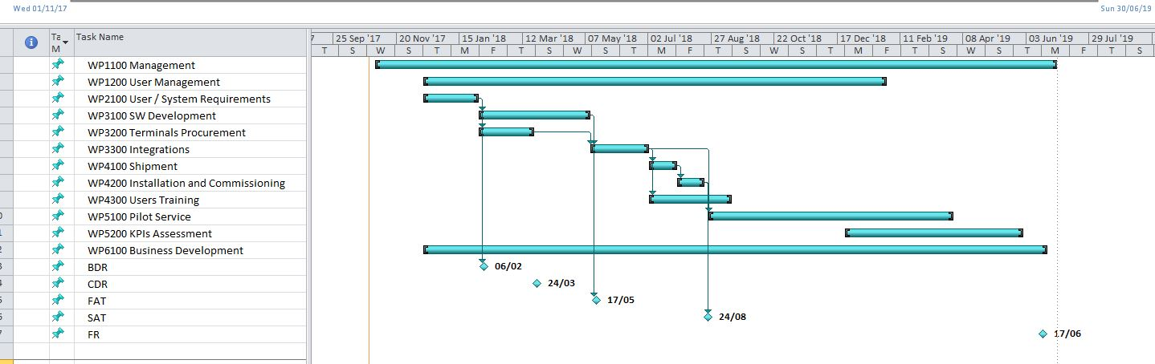

FINANCIAL Proposal

Cost and Price Summary

The cost and price for the project is as defined in the following table.
[When mentioning the Price of the activity, please, refer to the amount to be funded by ESA. The total cost of the activity is the complete activity cost composed of the ESA funding (firm fixed price to ESA) and the company’s contribution.

Table G.28 Cost and Price Summary
 |  | Contractor |  | Subcontractor 1 | Subcontractor ..
Tenderer’s Complete Name and Legal Nature |  | ........ |  | ........ | ........
SME |  | yes/no |  | yes/no | yes/no
Country (2-letter ISO code) |  | XX |  | YY | ZZ
Source of Co-financing (e.g. private investment, existing profits…) |  | ........ |  | ........ | ........
Provide the cost/price for the service development (excluding optional new product/technology development):
Service Development Total Price/Cost per entity |  | Price €........  Cost €........ |  | Price €........  Cost €........ | Price €........  Cost €........
Service Development: |  |  | Price €........  Cost €........  Price/Cost % …..
Optional Product/Technology Development: |  |  | Price €........  Cost €........  Price/Cost % …….
Sum Total Cost/Price | Price €........  Cost €........  Price/Cost %.......

Table G.29 External Service Providers
Service Provider | Country  (ISO Code) | Charged to Entity | Nature of the service | Cost Breakdown in Euro | Cost in Euro
Service Provider 1 | … | Prime | … | Number of units, €/unit €…,… | €…,…
Service Provider 2 | … | Subcontractor 1 | … | €…,… | €…,…
Service Provider 3 | … | Subcontractor 1 | … | €…,… | €…,…
… | … | … | … | … | …
Costs related to marketing activities (PR material, participation in conferences, exhibitions, etc.) are eligible up to 3% of the total cost.]
Please explain if and how such expenditures are planned to be spent outside of the countries of the bidding consortium

Table G.30 Expenditure Outside of the Bidding Consortium
Destination of Expenditure | Total Expenditure | Country | Nature of Expenditure, Potential Supplier(s) and Justification
… | … | … | …

PSS Forms
The PSS forms are attached in Annex PSS Forms for the Tenderer and for each of the proposed Subcontractor(s), showing, per entity, the total cost of the proposed work (i.e. including the entity’s share):
PSS-A1;
PSS-A2 (including Exhibits A and B, where applicable);
PSS A8 (reflecting the lowest level of the WPDs);
PSS A15-1.

The PSS forms in Excel format can be downloaded from EMITS, Reference Documentation > Administrative Documents > PSS Forms. The PSS Forms shall be signed (in particular the PSS-A1 and A2) by an authorised representative of the relevant contractors (Prime and each subcontractor, as relevant). Insert in this template the scanned PSS-A1 and PSS-A2 forms signed.
Notes for the compilation of the PSS Forms:
- PSS-A1 shall include the validity period covering the full duration of the project
- PSS-A2 shall include Exhibit A (other direct cost elements) and Exhibit B (travel plan and cost detail)
- In order to facilitate the participation of the key users to major projects reviews (typically, BDR and FR), travel costs incurred by users can also be included in the project costs
- Contributions from users and/or other stakeholder(s) can be recognised as allowable cost of the project. These contributions must be restricted exclusively to the demonstration project supported by ESA. They must be recorded in the PSS-A2 form(s) of the Tenderer (or its Subcontractor, where applicable) under “OTHER COST ELEMENTS”, and be further detailed in a letter of support signed by the user or stakeholder and in the Exhibit A of the relevant PSS A2 form, indicating the number of hours and hourly rates, facilities (if any) and the WP number(s) to which the users/stakeholder contributes
- All hardware, software and or services procured for the project shall be listed in the PSS-A2 under the voice 3.6-External Major Products (for hardware and software) and 3.7-External Services (for services). These costs shall be broken down detailing each single cost element in the Exhibit A of the PSS-A2, indicating the number of units and the total costs. The cost elements detailed in exhibit A shall be self-explanatory
- Hardware and software whose use is not limited to the demonstration project shall be amortised over its lifetime and only the period (months) in which they will be used for the project shall be listed as eligible project costs
- All hardware, software whose cumulative value exceed 10.000 Euro shall be provided with details of the procurement source (Name of the company and country)
- All external services whose cumulative value exceed 10.000 Euro shall be provided with details of the procurement source (Name of the company, country, number of man hours quoted and rate/hour, detailing any major additional cost item quoted in the service)
- If the country of procurement of hardware, software and/or external services is different from the one of the company that is procuring them, an approval of the National Delegation of the country may be required. It is duty of the prime contractor to inform the National Delegation of the intention to procure the item outside the country of origin and seeking for its approval
- PSS-A8 shall be compiled taking into account the WPs for which a WPD does exist. Typically, if the WBS is structured with a two levels WPs, the PSS-A8 shall refer to the WPs of Level 2, e.g. WP1100, WP1200, .., WP2100, WP2200, …
- PSS_A15 shall show the full cost profile of the company disbursement, and the payments received
from ESA (e.g. 50% of the project costs) reflected in the Milestone Payment Plan; the advance payment shall not be recorded

Annex G - PSS Forms

PSS-A1;
PSS-A2 (including Exhibits A and B);
PSS A8;
PSS A15.1.

Source of the Entity Contribution
The source of the entity contribution (including from any private third party) to the overall development costs is as follows:
Tenderer name (tenderer): ….
Candidate Subcontractor 1 name (subcontractor): …….
Candidate Subcontractor …. name (subcontractor): …….

It is confirmed that, in all cases, the entity contribution excludes:
overheads included in rates charged to the Agency for the contract, or any other contract with the Agency, or sub-contract awarded under an Agency contract
Examples of possible sources of co-funding are: existing funds in bank account coming from sales/profit, already approved/prospective bank loan, investment from external source e.g. private investment funds, other contributions. EU and/or national funds coming from e.g. R&D programmes are not allowed.
The purpose of this information is to provide evidence on the capabilities of the involved company(ies) to pay their share of the cost of the proposed activity elements (procurements, facilities, manpower) and, as such, can serve the obligations of the activity.
The bidder(s) is(are) kindly invited to provide evidence of the co-funding in the form of a letter(s) of commitment from investor(s), bank guarantee(s), loan(s) or own resources (e.g. cash and other liquidity).

Statement of Profit
This financial offer is exclusive of profit.

Currency and Conversion Rates
This financial proposal is presented in Euro. All members of the Bidding Team are located in countries participating in the Euro, so no currency exchange rates are applicable.
or include and complete the following information for all members of the Bidding Team located in countries not participating in the Euro.

The following table identifies the entities within the Bidding Team who are not located in countries participating in the Euro and the currency exchange rates that have been applied in each case.
This exchange rate shall be stated in the PSS forms and shall be clearly explained in Exhibit A to form PSS-A2. Any other factors (e.g. hedging costs, forward buying rates, etc.) used for the purpose of its calculation shall be indicated.

Table G.6.2 Summary of exchange rates applied
Summary of exchange rates applied
Entity | National Currency | Exchange Rates Applied | Detailed in the Entity’s PSS-A2 Form and its Exhibit A | Other Factors Used to Calculate the Exchange Rates
… | … | … | yes/no | …
… | … | … | yes/no | …
… | … | … | yes/no | …
… | … | … | yes/no | …

Should any country(ies) to which the above entity/entities belong adopt the Euro following the submission of proposals, the applicable conversion rates shall be the ones then adopted by the appropriate European Authorities.

Type of Price
The price quoted is a Firm Fixed Price.

Quotations Free of Taxes and Customs Duties
The price quoted is free of taxes and customs duties.
or
We believe that we cannot obtain exemption from tax or customs duties because ……. Consequently, we consider that we will remain subject to the payment of taxes or customs duties under the conditions indicated below:
Applicable rates: | ……
Estimated total tax amount: | ……
Estimated total customs duty amount: | ……

Milestone Payment Plan
The proposed milestone payment plan is detailed in the tables below. It is based on the information provided in for PSS-A15.1 and reflects the economic reality of the project.
The proposed payment plan shall take into account Article 3 of the Draft Contract and the following provisions:
- All claims for payment shall be linked to the achievement of defined schedule milestones
- These milestones are to be in the form of significant events in the programme, to be selected on the basis of providing a check point for progress of the work performed
- The payment plan shall consist of progress and final payment milestones only, adding up to the total contract price
- The final payment shall not be less than 15% of the total contract price also taking into account any offsetting of the Advance Payment(s) amount
Table G.31 Milestone Payment Plan
Milestone Description | Schedule Date | Payments from ESA to Contractor  (in Euro) | Country (ISO Code)
Progress (MS1): Upon successful completion of WP … and/or successful [review and] the Agency’s acceptance of all related deliverables. | T0 + … months | €…,… | …
Progress (MS2): Upon successful completion of WP … and successful [review and] the Agency’s acceptance of all related deliverables. | T0 + … months | €…,… | …
Progress (MS..): Upon successful completion of WP … and successful [review and] the Agency’s acceptance of all related deliverables. | T0 + … months | €…,… | …
… | … | … | …
Final Settlement (FR): Upon the Agency’s acceptance of all deliverable items due under the Contract and the Contractor’s fulfilment of all other contractual obligations, including submission of the Contract Closure Documentation. | T0 + … months | €…,…  (min. 15%) | …
 | Total | €…,…

Include the following explanatory text and table if you wish to propose an advance payment plan.
The advance payment shall take into account Article 3 of the Draft Contract and the following provisions:
- An advance payment is not granted automatically, it is required to demonstrate a significant need for cash disbursement at the beginning of the execution of the contract.
- The amount of any proposed advance payment and the corresponding amount(s) to be offset against the relevant milestone payment(s) shall be clearly stated in Euro, along with a justification for the need for cash disbursement at the beginning of the execution of the contract. Nevertheless, whenever an SME (as per definition in http://eur-lex.europa.eu/legal-content/EN/TXT/PDF/?uri=CELEX:32003H0361&from=EN) is involved as prime or subcontractor, it shall be entitled to a 35% advance payment irrespective of any cash disbursement needs. Further, the SME has the right to request the offset of the 35% advance at the end of the contract i.e. the two last milestones (ideally 25% at the last milestone and 10% at the preceding milestone), if this can be justified in view of the economic progress in the contract.

[if needed]: An advance payment is proposed in the table below. This proposal reflects the need for significant cash disbursement at the beginning of the activity, as shown in the cash flow profile presented in form PSS-A15.1.

[in case of no SME involved]: The reasons for this early cash disbursement are …….
Table G.32 Advance Payment Plan
Prime (P) | Company Name | Country  (ISO Code) | Advance Payment (in EUR) | Off-Set against | Off-set by (amount in EUR) | Payments from ESA to Contractor  (in Euro) Accounting for Offset | Condition for release of the Advance Payment (if applicable)
P | … | … | … | MS1 | €…,… | €…,… | After signature of the Contract by both parties
 |  |  |  | … | €…,… | €…,… | After signature of the Contract by both parties
 |  |  |  | … | €…,… | €…,… | After signature of the Contract by both parties
 |  |  |  | … | €…,… | €…,… | After signature of the Contract by both parties
 |  |  |  | FR | €…,… | €…,…  (min. 15%) | After signature of the Contract by both parties

CONTRACTUAL Proposal

Compliance with the Contract Conditions
The contract conditions have been read, are understood and accepted. No sales conditions of our own are applicable.

Tenderers shall explicitly state that they have read, understood and accepted the Personal Data Processing Annex (PDPA) to the Contract. This Annex forms an integrated part of the Contract and the Tenderer’s attention is drawn to the fact that it will not be subject of separate signatures. Should the tender lead to a Contract award, the PDPA will enter into force upon signature of the Contract by both Parties

Insurance Waiver
A waiver of subrogation rights from our insurer will be available at the time of contract signature.
or
A waiver of subrogation rights from our insurer will not be available. The hold harmless agreement specified in Clause 18.1.6 of the General Clauses and Conditions for ESA Contracts shall apply.

Statement Relating to Export Import Licences / Authorisations and Related Documentation
There are no export or import restriction issues and thus no need to obtain specific licences or authorisations.
or include and complete the following statements as appropriate
Export or import restrictions and/or a need of adequate licences or authorisations exist, and the status regarding such requirements is at present the following:
- the Tenderer/Subcontractor … (name) has obtained the following authorisation(s) in order to submit this tender: ….
and/or
- the Tenderer/Subcontractor … (name) will need to obtain, prior to the placing of a Contract, the following authorisation(s): ....
and/or
- the Tenderer/Subcontractor … (name) will need to obtain the following authorisation(s) for the implementation of the contract: ....

Activity Price is what is requested from ESA
Activity Cost is the total cost planned for carrying out the activity
Commercial Off The Shelf
This part may or may not need to be filled in, depending on the scope of the proposal (please refer to the related explanatory notes to determine if they apply or not).
This part may or may not need to be filled in, depending on the scope of the proposal (please refer to the related explanatory notes to determine if they apply or not).

